Designing an Access Database
Chapter
1

Microsoft Access is a database program. A database is just a collection of specific data for a set of items. For example, the Telephone Directory is a database. It lists the initials, surname, street address and telephone number for each person in a particular geographical area. However the use of a telephone book in hardcopy is limited compared to a computerised database. For example, imagine how long it would take you to list the names and telephone numbers of all people who lived in South Geelong just looking through the telephone book. On the other hand, if we had the telephone book records entered into a computerised database we can set Access to find this information and it would do so in a matter of minutes.

Table Structure

We can use a database wherever we keep specific items of data for people or objects. For example, supplier details, staff details or product details.

The columns of details are called Fields.

Each set of data entries in Fields is called a Record.

A collection of Records is called a Table.

One or more Tables in a collection are called a Database.

Fields
Supplier Table

Supplier | Address | City | Post  code | Contact
Touch Stone | 1 Apple Ln | Melbourne | 3000 | Daniel Leman
Parachute Pictures  Records | 1000 High St | Sydney | 2000 | Skye Hie
Village Roadshow | 22 Main Rd | Melbourne | 3000 | Adam Forewater

There are various types of database design. Microsoft Access creates a relational database type.
A simple database might consist of one table about one entity. For example a list of contact details for Customers. For each Customer details such as Name, Phone Number, Address etc are stored.

No | Title | First Name | Surname | Phone
1 | Mr | Jim | James | 02 9876 5463
2 | Ms | Jane | Plane | 03 9546 8521
3 | Miss | Jill | McDonald | 04 8568 1549

A simple database like this is easy to set up. However things get a little more complicated when you decide to store more details such as details of Contact with customers – for example the date you contact the customer and what you talked about. You could add a couple of columns to the table above however each time you made contact you would have to repeat the details of First Name, Surname and Phone number as shown below.

No | Title | First Name | Surname | Phone | Date | Topic
1 | Mr | Jim | James | 02 9876 5463 | 7/5/01 | Lost Order
2 | Ms | Jane | Plane | 03 9546 8521 | 7/5/01 | New binding product
3 | Miss | Jill | McDonald | 04 8568 1549 | 7/5/01 | Setup meeting
4 | Ms | Jane | Plain | 03 9546 8521 | 8/5/01 | Setup Appointment
5 | Mr | Jim | James | 02 9876 5463 | 8/5/01 | Found Order
6 | Mr | Jim | James | 02 9876 5463 | 9/5/01 | Check Order Received
7 | Miss | Jill | McDonald | 04 8568 1549 | 9/5/01 | Change Meeting to 11/5

The table above repeats information enlarging the database unnecessarily and increasing the time taken to enter data. It also presents problems of data integrity. For example if an entry is made incorrectly – such as incorrect spelling of Plain in record 4. Or if a client’s phone number changes – do you change all the entries for the phone number. The database works more efficiently if the table is split up into two tables, one for customer details and another that lists contacts with a distinguishing field that appears in both tables.

Customer No | Title | First Name | Surname | Phone
1 | Mr | Jim | James | 02 9876 5463
2 | Ms | Jane | Plane | 03 9546 8521
3 | Miss | Jill | McDonald | 04 8568 1549

Contact No | Surname | Date | Topic
1 | James | 7/5/01 | Lost Order
2 | Plane | 7/5/01 | New binding product
3 | McDonald | 7/5/01 | Setup meeting
4 | Plain | 8/5/01 | Setup Appointment
5 | James | 8/5/01 | Found Order
6 | James | 9/5/01 | Check Order Received
7 | McDonald | 9/5/01 | Change Meeting to 11/5/01

Relationships between Tables

A relationship can be created between the Customer table and the Contacts table.

Each customer appears only once in the Customer Table. However there are many occurrences of the customer in the Contacts table. This is called a One-to-Many relationship.

Relationships between tables can be defined even before entering any data.

Data that is stored in a relational database is located through its unique identifier or Primary key. For example displaying a list of contacts made with a particular customer is achieved by using the Customer ID, the Primary key of the Customer table and accessing all records with this Customer ID in the Contacts table.
Customer table
Contacts table

Customer Id | Title | First Name | Surname | Phone
1 | Mr | Jim | James | 02 9876 5463
2 | Ms | Jane | Plane | 03 9546 8521
3 | Miss | Jill | McDonald | 04 8568 1549

Contact No | Customer Id | Date | Topic
1 | 1 | 7/5/01 | Lost Order
2 | 2 | 7/5/01 | New binding product
3 | 3 | 7/5/01 | Setup meeting
4 | 2 | 8/5/01 | Setup Appointment
5 | 1 | 8/5/01 | Found Order
6 | 1 | 9/5/01 | Check Order Received
7 | 3 | 9/5/01 | Change Meeting to 11/5/01

The resulting report would include the following details.

Contacts

Mr | Jim | James | 02 9876 5463

No | Date | Topic
1 | 7/5/01 | Lost Order
5 | 8/5/01 | Found Order
6 | 9/5/01 | Check Order Received

Relationships between Tables come in one of three forms.

- One to One

- One to Many

- Many to Many

One to One is where a particular item appears once in one table and once in another table. This is not often used. Eg One video store has one manager – the Video Store number is the same in both tables – 3 records for three stores and three managers.

Manager Details Manager Work

No | Store | Surname | First Name |  | No | Start Date | Salary | Awards
1 | 52 | Jones | Jim |  | 1 | 11/12/89 | 52000 | Gold
2 | 28 | Smith | Jen |  | 2 | 15/02/95 | 63000 | Gold
3 | 32 | Wilder | Jan |  | 3 | 04/03/99 | 48000 | Silver

One to Many is where a particular item appears once in one table but many times in another table- this is the most common relationship. Eg One customer can be contacted many times.
Customer table
Contacts table

Customer Id | Title | First Name | Surname | Phone
1 | Mr | Jim | James | 02 9876 5463
2 | Ms | Jane | Plane | 03 9546 8521
3 | Miss | Jill | McDonald | 04 8568 1549

Contact No | Customer Id | Date | Topic
1 | 1 | 7/5/01 | Lost Order
2 | 2 | 7/5/01 | New binding product
3 | 3 | 7/5/01 | Setup meeting
4 | 2 | 8/5/01 | Setup Appointment
5 | 1 | 8/5/01 | Found Order
6 | 1 | 9/5/01 | Check Order Received
7 | 3 | 9/5/01 | Change Meeting to 11/5/01

Many to Many is where a particular item occurs many times in one table and many times in another table. This type of relationship is to be avoided. It is solved by creating an extra table that enables a one to many and another one to many – it will be examined in detail shortly.

Video Name | Suppliers | Supplier Address | Supplier City | Supplier Post Code | Supplier Contact | Category | Rating | Purchase Cost | Number of Copies | Date Purchased
My Best Friends Wedding | Touch Star | 1 Apple Lane | Melbourne | 3000 | Daniel Leman | Comedy | PG | $130.00 | 2 | 1/06/98
Scream | Village Roadshow | 22 Main Road | Melbourne | 3000 | Adam Forewater | Horror | M | $120.00 | 1 | 1/05/98
The Shawshack Redemption | Parachute Pictures | 1000 High Street | Sydney | 2000 | Skye Hie | Drama | M | $135.00 | 4 | 1/04/98
Sense and Sensibility | Touch Star | 1 Apple Lane | Melbourne | 3000 | Daniel Leman | Romance | G | $130.00 | 3 | 11/04/98
Three Weddings and a Funeral | Village Roadshow | 22 Main Road | Melbourne | 3000 | Adam Forewater | Comedy | M | $120.00 | 1 | 23/05/98
White Sands | Parachute Pictures | 1000 High Street | Sydney | 2000 | Skye Hie | Drama | M | $135.00 | 2 | 25/06/98
The Flintstones | Touch Star | 1 Apple Lane | Melbourne | 3000 | Daniel Leman | Comedy | G | $135.00 | 1 | 25/06/98
Santa Clause | Parachute Pictures | 1000 High Street | Sydney | 2000 | Skye Hie | Comedy | G | $130.00 | 2 | 20/04/98
Mr Been - Red | Village Roadshow | 22 Main Road | Melbourne | 3000 | Adam Forewater | Comedy | G | $120.00 | 1 | 20/04/98
Mr Been - Blue | Touch Star | 1 Apple Lane | Melbourne | 3000 | Daniel Leman | Comedy | G | $135.00 | 2 | 23/05/98
Mr Been - Yellow | Parachute Pictures | 1000 High Street | Sydney | 2000 | Skye Hie | Comedy | G | $130.00 | 1 | 12/03/98
Mr Been - Green | Village Roadshow | 22 Main Road | Melbourne | 3000 | Adam Forewater | Comedy | G | $120.00 | 2 | 20/04/98
Mr Been - The Movie | Touch Star | 1 Apple Lane | Melbourne | 3000 | Daniel Leman | Comedy | G | $135.00 | 1 | 20/04/98
Emma | Parachute Pictures | 1000 High Street | Sydney | 2000 | Skye Hie | Romance | G | $130.00 | 2 | 12/04/98
The Creature | Village Roadshow | 22 Main Road | Melbourne | 3000 | Adam Forewater | Horror | M | $120.00 | 1 | 12/03/98
The English Patient | Touch Star | 1 Apple Lane | Melbourne | 3000 | Daniel Leman | Romance | M | $120.00 | 2 | 23/05/98
The Sting | Parachute Pictures | 1000 High Street | Sydney | 2000 | Skye Hie | Comedy | G | $135.00 | 1 | 20/04/98

Databases are usually made of more than one table. The reason for this is to reduce the size of the database so that repetitive information is not entered. For example look at the table on the previous page. This table lists all the Videos in a store’s collection. For each video it lists

- Video Name
- Supplier
- Supplier Address
- Supplier City
- Supplier Post Code
- Supplier Contact
- Category
- Rating
- Purchase Cost
- Number of Copies
- Date Purchased

This information could be put into a table in Access using each of these items as fields. However each time we enter the details for a new video, we would be repeating data about suppliers that is already entered for a previous Video.

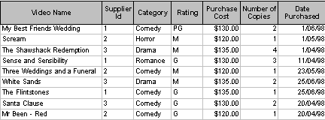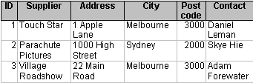Look at the table again on the previous page. The Supplier details are listed over and over again. To save space in a database this repetitive information can be stored just once in a Supplier table and a reference to the information made in the Video table
Video Table
Supplier Table

Each time 1 appears in the SupplierID field in the Video table, Access can look up the Supplier table to get details for Supplier 1 if it needs to.

Relationships between tables mean Access can make better use of the information by using more than one table at a time.

Designing Tables

Dividing data into tables is the basis for a good database. When deciding on the tables required you should look at your information requirements from the database. Each table should be based on one element of the system.

Obvious elements are people involved, eg the customer, the employee, the supplier.

Other elements might be what is being used. For example Videos in a video store, Products for sale in a retail store, Treatments available at a surgery, Subjects available at an educational institution.

Then there is how these elements interact, eg sales, enrolments, borrowings.

What is necessary

When deciding on the fields to use in a table you should think about what is necessary to record. A particular piece of information may be redundant in one table while very useful in another. For example a Student details list would not need the students Shoe Size. However a list of uniform details for Soldiers in the army may include a field Shoe Size for uniform requirements.

Basic components

Each field should be broken down to its smallest component. For example an individual’s name should not be recorded in one field, it should be broken into First name and Surname. This enables more use of the data, for example salutations in letters, addressing mail, sorting by Surname, etc.

Constant values

Where a calculation of data is required the values required completing that calculation should be in fields rather than the end result. For example if a student’s age were recorded in a table it would need to be updated regularly. Whereas if the birth date is entered, it can be used in a query calculation to display the student’s current age. This negates the need to keep updating the age field and ensures that the information is always accurate.

When creating a table you should think about each item of data and to which element it ultimately belongs. This is called normalisation.

This table lists all the Videos in a store’s collection. For each video it lists

- Video Name
- Supplier
- Supplier Address
- Supplier City
- Supplier Post Code
- Supplier Contact
- Category
- Rating
- Purchase Cost
- Number of Copies
- Date Purchased

This list could be broken into two tables – one for Supplier and another for Videos. Notice that Supplier appears each table. This field will ultimately be used to create a relationship between the two tables.

- Supplier
- Supplier Address
- Supplier City
- Supplier Post Code
- Supplier Contact
- Video Name
- Supplier
- Category
- Rating
- Purchase Cost
- Number of Copies
- Date Purchased

Practice Exercise 1.1

- Split this list into two tables – one for Employees the other for Department. One field will appear twice.

 | Employees | Departments
- Employee ID
- Title
- First name
- Surname
- Position
- Department Name
- Building
- Department Head
- Starting date
- Salary

Creating a Relationship Between Tables

At Luscious Landscapes the admin staff need to know which Supplier supplies each of the plant Stock. As we have seen with the Videos it is impractical to store details about suppliers on every card. We can create a relationship between the Supplier table and the Stock Table at Luscious Landscapes.

- Start Access and open the file Ch1 Relationships
- Click on the Tables tab if necessary

Before we can create a link between the two tables we must make sure they are compatible. ie. Each must contain a common field, in this case SupplierID – and it MUST be the Primary key in one of the tables.

We have inserted a SupplierID field into the Stock table so that we can create a link between the Supplier table and the Stock table.

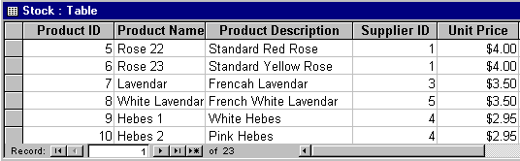

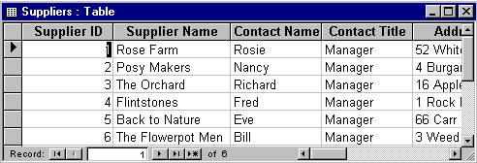
You can check the Data type and Name in the Design View of the Table.

For tables to relate to one another a common field must appear in both tables. The field must have the same name in both tables and be of the same Data Type. The common field should also be a Primary key in one of the tables.

- Click on the Suppliers table and click on Design view

- Click on the Field name SupplierID

In the Suppliers table Supplier ID is the Primary Key – its Data Type is AutoNumber which has to be related to Supplier ID in the Stock Table with the Number DataType with Long Integer Field Size.
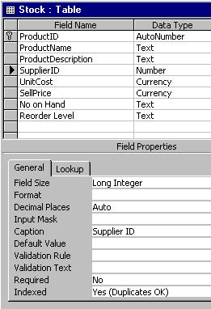
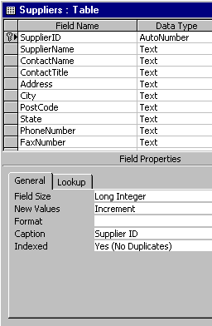

To Create a One to Many Relationship between Tables

- Click on Tools in the Menu Bar

- Click on Relationships – the Show Table window should appear (if it doesn’t appear click on Relationships ➢ Show Table in the Menu bar
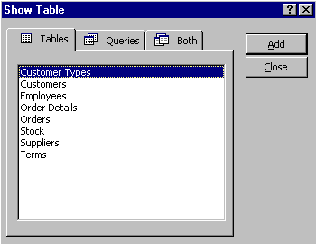

- Click on Stock then Add
- Click on Suppliers then Add
- Click on Close

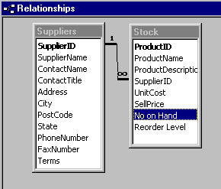
The tables will appear in the Relationship window

Now we want to set up a relationship between the Suppliers table and the Stock table. Each Supplier appears only once in the Suppliers table but many times in the Stock table, so we are setting up a one-to-many relationship from the Suppliers table to the Stock table. We will set the relationship now.
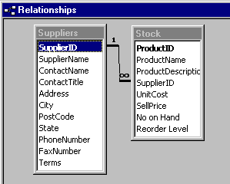
- Click on SupplierID field in the Suppliers table and drag over to the SupplierID field in the Stock table - The Relationships window will appear as shown below

- Ensure your tables are as they appear here
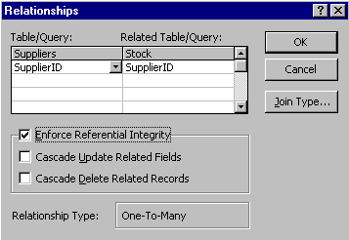
Primary Key
Enforce Referential Integrity ensures that we cannot enter a Supplier ID into the Stock table that is not already in the Suppliers Table
One
Many

- Click on Enforce Referential Integrity

- Click on Create

The Relationship will be created as shown in the Relationships window.
This relationship shows that one Supplier can supply many Stock items.
- Close the Relationships window Saving the layout changes

Let’s get serious about this database and put all the information we need to keep track of Customers, Orders, Stock, Employees and Suppliers into the database. To do this we need to work out the fields

We already have the Suppliers table, the Stock table. Also an Orders table is used to record when a customer buys. This table must be separate from the Customers and the Stock tables as many Customers can Order many Stock items and a Stock item can be ordered by Many Customers. So to try and create a direct link between the Customer and Stock table just would not work.

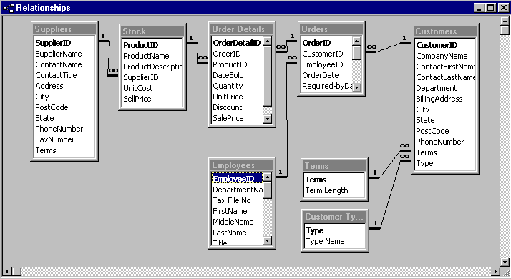
To link the other tables relationships must be created between each table.

- Click on Tools ➢ Relationships in the Menu bar
- Click on the Show Table button in the toolbar

- Click on Orders in the Show Table window and Add
- Click on Order Details in the Show Table window and Add
- Click on Employees in the Show Table window and Add
- Click on Customers in the Show Table window and Add
- Click on Close to close the Show Table window

- Create One to Many relationships between

- Stock and Order Details with the ProductID field

- Customers and Orders with the CustomerID field

- Employees and Orders with the EmployeeID field

- Orders and Order Details with the OrderID field

- Close the Relationships window Saving the changes

Creating Lookup Data

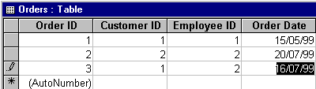
While it is all very well having links between tables and using relatively small fields to link the two, it can be difficult for the user to enter the right data, ie remember ID numbers. Look at the two versions of the Orders table below. Each table stores exactly the same data.

This table uses Lookup data so that for example instead of CustomerID 1 – the actual Company name for Customer ID 1 is displayed. Similarly for the EmployeeID field, the name of the Employee is displayed rather than the ID. This makes it easier for the user to enter details.
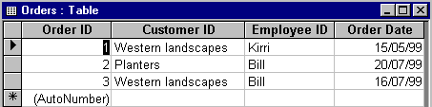
- Open the Design view of the Orders table

- Click on the Data Type column of the CustomerID field

- Click on the Lookup Wizard (at the end of the data type list)
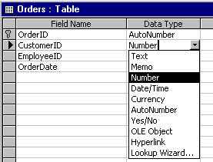
Lookup Wizard
The Lookup Wizard starts with the first screen as shown on the following page.

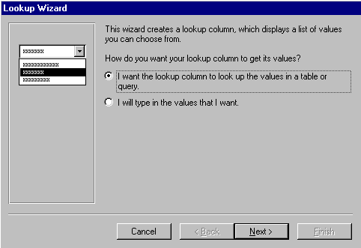
- Click on the top choice so the values are chosen from a list of values in another table

- Click on Next

This step is to choose which values you are choosing from. Because we want the Customer data in the Order table to be consistent with the Customer data in the Customers table……

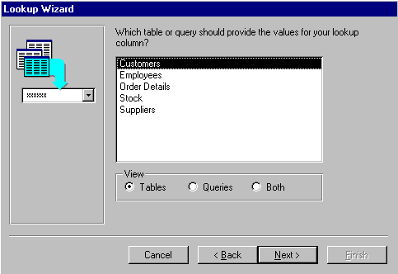
- Choose Customers out of the list of tables

- Click on Next

- Put CustomerId and CompanyName in the Selected Fields box

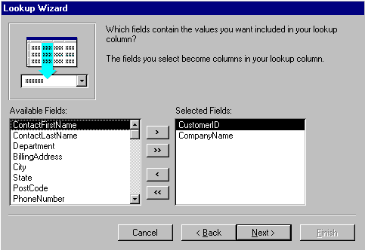
- Click on Next

- Adjust the width of the column if necessary
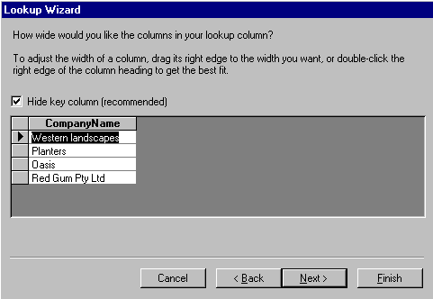
- Click on Next

- Keep the label CustomerID
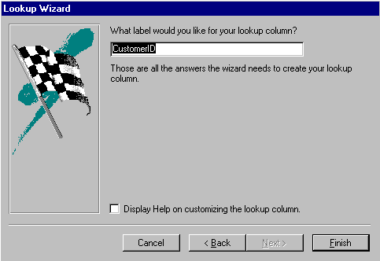
- Click on Finish

- Click on Yes to the prompt to save the relationships
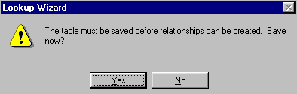

- Switch to Datasheet view saving the changes
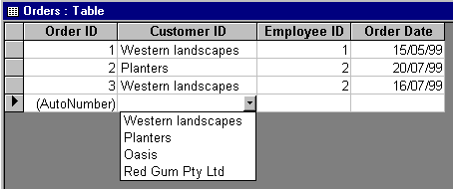

Now the Company Name will be selected to be displayed in the Customer ID while the actual Customer ID number is being stored in the Orders table.

Practice Exercise 1.3

- Repeat to create a Lookup field for Employee ID in the Orders tables
- Open the design view of the Orders table

- Click the EmployeeID field and select LookUp in the Data type column to activate the LookUp Wizard

- Use the following setup at the Selected fields step
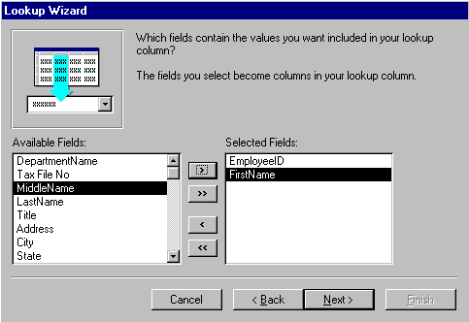
- When finished click on the Datasheet view button for the Orders table
Now when Order details are entered in the Order table the Employee’s name can be used to enter the Employee ID.

- Close the Orders table

Field Properties

Field properties were introduced in Introduction to Microsoft Access. Here you will revise the Field Properties then you look specifically at Input Masks and Data Validation.

Field Size sets the size of a field

Format sets the way a value is displayed – but does not alter how it is stored

Input mask displays appropriate characters – eg slashes for a date, and is also used as a validation tool by ensuring that appropriate data is entered – eg two spaces for the day of month so the 7th is entered as 07.

Caption Text entered here becomes the Label of the field in forms and reports

Default value Data entered here will be automatically entered into the table when a new record is added – but it can be changed if necessary. Eg State with Default value Vic if 99% of customers reside in Victoria

Validation Rule A rule by within which data entered into the field must fall eg en expiry date on a credit card must be after the current date

Validation Text The message that appears if Validation rule is not met when entering data into the field

Required Property A Yes setting here will require all new records to have data entered in this field – new records without data in this field will not be recorded

Allow Zero Length Allows zero length values in the field

Indexed A Yes setting here will enable the field to be used efficiently for sorting or searching data. A Primary key is always indexed, however other fields such as Surname can be indexed as well.

Input Masks

Input masks are used to assist users in entering appropriate data and in an appropriate format. For example if a code should be all uppercase or consist of 4 uppercase letters then four numerals, or a date should have a four digit year.

An input mask consists of literal characters (such as spaces, dots, dashes, and parentheses) that separate blanks to fill in.

The literal characters may appear like this in the field – you can then fill in the field with just the numerals.

(_ _ _) _ _ _-_ _ _ _ (003) 987-5847

Setting an InputMask definition consists of literal characters and special characters defined below. Input masks are mostly used in Text and Date/Time fields, and also in Number and Currency fields.

Input Mask Definition

The input mask definition can contain up to three sections separated by semicolons (however very often only has the first section)

For example,

(999) 000-0000;0;" ".

Section | Meaning
First | The actual input mask
Second | Determines whether to actually store the literal display characters ie the dashes, slashes etc.  0 will store literal characters with the value entered so 234-5674635 would store all numbers and the dash  1 or leave blank will store only characters entered in blanks so 234-5674635 would be stored as 2345674635
Third | Character that is displayed for blanks in the input mask. You can use any character; type " " (ie. double quotation marks, space, double quotation marks) to display a space. The underscore ( _ ) is used automatically if you leave this section blank

Valid Input Mask Characters

The following table is taken from the Microsoft Help – Valid Input Mask Characters

Character | Description
0 | Digit (0 through 9, entry required; plus [+] and minus [-] signs not allowed).
9 | Digit or space (entry not required; plus and minus signs not allowed).
# | Digit or space (entry not required; blank positions converted to spaces, plus and minus signs allowed).
L | Letter (A through Z, entry required).
? | Letter (A through Z, entry optional).
A | Letter or digit (entry required).
a | Letter or digit (entry optional).
& | Any character or a space (entry required).
C | Any character or a space (entry optional).
. , : ; - / | Decimal placeholder and thousands, date, and time separators. (The actual character used depends on the regional settings specified by double-clicking Regional Settings in the Windows Control Panel.)
< | Causes all characters that follow to be converted to lowercase.
> | Causes all characters that follow to be converted to uppercase.
! | Causes the input mask to display from right to left, rather than from left to right. Characters typed into the mask always fill it from left to right. You can include the exclamation point anywhere in the input mask.
\ | Causes the character that follows to be displayed as a literal character. Used to display any of the characters listed in this table as literal characters (for example, \A is displayed as just A).

Input Mask Examples

The following table shows some examples of input mask definitions and examples of values you can enter into them.

Input mask | Possible Displays
(000) 000-0000 | (055) 557-0278
(999) 999-9999! | (055) 557-0278 | ( ) 557-0278
(000) AAA-AAAA | (512) 123-TOYS
#999 | -19 | 1234
>L????L?000L0 | AREENBR987N3 | ABC D 587C9
>L0L 0L0 | B2B 9U4 | N8T 3E5
00000-9999 | 74556- | 74556-8995
>L<?????????????? | Elizabeth | Henry
ISBN 0-&&&&&&&&&-0 | ISBN 1-44821-603-7 | ISBN 0-24-852147-5
>LL00000-0000 | EA87451-95146

Input masks are often applied automatically when using the Wizard to create a table.

- Open the Customers table in Design View
- Click on the State in the Customer table
- Click in the Input Mask for State and type >LLL

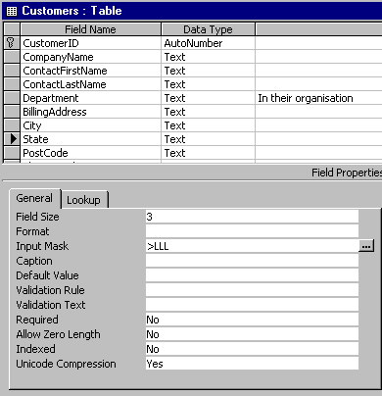
This will cause any city entered here to have an Uppercase letters first followed by all lowercase letters.

This will enter letters in uppercase and require the entry of state whenever a new record is added to the customers table.

The Input Mask Wizard

The Input Mask Wizard is useful for applying standard Input Masks.

- Click on the Phone Number field in the Design View of the Customer table
- Click in the Input Mask property box
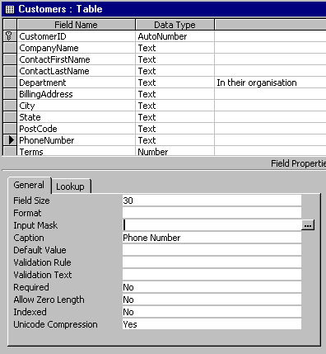

- Click on the Build button at the end of the property box

Build

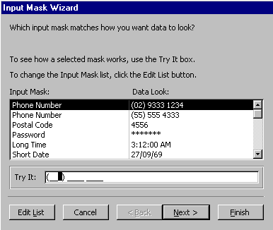
The Input Mask Wizard will appear as shown above. You can click on the input style you require for the data.

- Click in the Try It box to view how the field will appear when data is being entered into it

- Click on Next
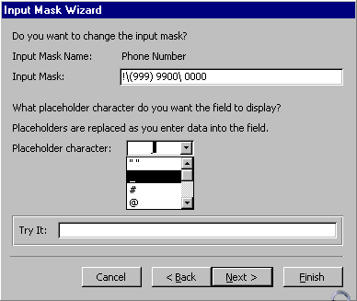
At this step you can select the symbol that will appear for each character placeholder.

- Click on the droplist button to view the choice

- Click on Next

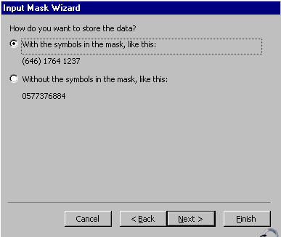

At this step you can choose to store the data with or without the characters.

- Click on Next

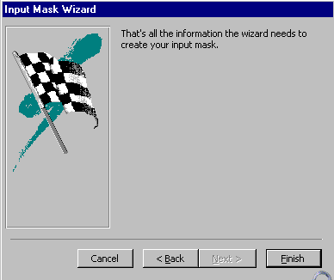
- Click on Finish

- Save and Close the table

Data Validation

Automatic Data Validation occurs via the data type for fields. For example text cannot be entered into a field with a Number type. Data Validation is also greatly improved when Lookup lists are used so that the data entered is predefined in a set list.

Data validation using the Validation Rule property will assist in ensuring accurate data is entered into a table. For example if there were a limit to the number of one item that a customer could purchase, 10 of one thing for example, then the Validation rule could be used to ensure that an entry over 10 in the Quantity field would be rejected. Or for example dates – a current financial year date is useful or a function to enter the current date in the default value. A percentage value of between 0 and 1.

Some examples of Validation Rules are given below with corresponding Validation Text.

ValidationRule | ValidationText
> 0 | Entry must be greater than 0
< 0 | Entry must be less than 0
<> 0 | Entry cannot be 0
> 25 Or Is Null | Entry must be blank or greater than 25
Between 0 And 100 | Entry must be between 0 and 100
Like "ASA????" | Entry must be 7 characters and begin with the letters "ASA".
>= #1/1/00# And <#1/1/01# | Entry must be a date in 2000.

The down side of applying a Validation rule is that a value is then required in that field by Microsoft Access. If the field will sometimes have no entry you can get around this by adding Or Is Null to the Validation rule and check that the Required property is set to No.

